**3.5**

“*If I own Playstation, I will play GTA 5. If I have time, I will play GTA 5. I play GTA 5. Therefore, I own Playstation or I have time.*”

**P =** *I own Playstation*

**Q =** *I will play GTA 5*

**R =** *I have time*

**S =** *I will play GTA 5.*

*T = I play GTA 5*

*U = I own Playstation*

*V = I have time*

**(P 🡪 Q) 🡪 (R 🡪 S) 🡪 T 🡪 (U && V)**

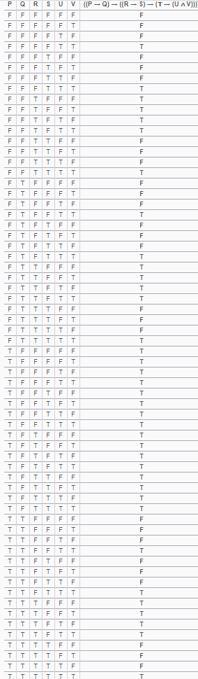

So it’s a valid statement.

**6.2**

**Read numerical values from the standard input until 0 is entered. Then find and print the difference between the maximal and minimal value.**

number = int(input('Enter a positive number : '))

a = number

b = number

while number != 0:

number = int(input('Enter a positive number : '))

if number > a:

a = number

if (number < b) and (number !=0):

b = number

print('The biggest number is ' + str(a))

print('The smallest number is ' + str(b))

print('The difference between the biggest and smallest number is ' + str(a - b))

6.9

For a given numerical value (natural number) print all of its digits in reverse order.

Example: (input) 5347, (output) 7, 4, 3, 5.

number = int(input('Pls write a positive number '));

reverse = 0

while (number > 0):

a = number % 10

number = number // 10

reverse = reverse * 10 + a

print(reverse)